<<Template Artikel Ilmiah>>

Nama Penulis
Afiliasi
Email korporat

Abstrak

Tujuan pembuatan template artikel ilmiah ini adalah untuk memberikan panduan umum bagi penulis dalam menyajikan hasil penelitian dan/ atau gagasannya pada Jurnal Publik. Metoda penyajian pada artikel ilmiah sebaiknya mengikuti pola umum yang biasa digunakan pada jurnal yang bereputasi, sehingga memudahkan penulis dalam mengirimkan artikel pada jurnal tersebut; penulisan karya ilmiah perlu disesuaikan pula pada disiplin ilmu yang menjadi kepakaran penulis. Artikel jurnal biasanya menggunakan sistematika yang terdiri dari: abstrak, kata kunci, pendahuluan, metodologi, hasil dan pembahasan, kesimpulan, ucapan terima kasih, dan referensi. Khusus untuk abstrak diharuskan mengandung unsur-unsur: tujuan, metodologi, hasil/ temuan penting, dan kesimpulan; apabila memungkinkan dapat ditambahkan narasi/ informasi mengenai: batasan penelitian, implikasi praktis, dan implikasi sosial. Umumnya penyajian abstrak tidak melebihi 200 kata.

Kata kunci: artikel ilmiah; sistematika; sitasi

1 Pendahuluan

Pada umumnya, karya tulis ilmiah berbentuk narasi yang bersifat argumentatif, yang digunakan di kalangan akademis dan/ atau peneliti untuk mengungkapkan informasi dalam bidang atau subjek tertentu. Secara umum, karya tulis ilmiah membahas sebuah subjek secara akurat, bersifat semi formal, impersonal, dan objektif dalam pengungkapan gagasan (Pribadi & Delfy, 2015). Karya ilmiah yang dipublikasikan merupakan kontribusi pemikiran untuk menjawab berbagai permasalahan yang terjadi pada kehidupan manusia (Rohmah, Huda, & Kusmintardjo, 2016).

Karya ilmiah merupakan refleksi dari pengalaman dan gagasan penulis dalam melakukan kajian/ penelitian, yang mencerminkan kekhasan, identitas, dan citra diri dari penulis. Namun demikian, perlu dilakukan standarisasi publikasi karya ilmiah untuk memudahkan penulis maupun pembaca dalam membangun alur pikiran gagasan yang dilahirkan oleh penulis. Pembuatan template ini bertujuan untuk memberikan panduan umum bagi penulis dalam menyajikan hasil penelitian dan/ atau pemikirannya pada karya ilmiah, walaupun pada hal-hal tertentu dapat dimodifikasi sesuai dengan bidang keilmuan dan gaya penulisan dari penulis.

2 Gaya dan Format Penulisan

Pada bagian judul dibuat ukuran huruf sebesar 14 pt, dicetak tebal (bold), dengan jenis huruf Times New Roman. Kolom judul dibatasi dengan dua spasi dengan badan artikel. Gunakan ukuran huruf 11 pt, dengan jenis huruf Times New Roman untuk badan artikel dengan pembatas antar baris menggunakan satu spasi, antar paragraph dibuat dua spasi, dan dibuat tiga spasi untuk membatasi badan artikel dengan judul di bawahnya. Artikel dibuat pada ukuran kertas B5-JIS (18.2x25.7 cm), dengan marjin kiri, dan kanan sebesar dua cm, sedangkan margin atas, dan bawah masing-masing sebesar 2.5 cm.

2.1 Rumus Matematika

Rumus matematika diberikan nomor yang ditandai mulai dengan (1) yang ditempatkan rata kanan, penulisan persamaan matematika ditempatkan 1.5 cm dari sisi kiri badan artikel. Untuk membuat persamaan matematika, gunakan simbol umum yang disepakati. Sebagai contoh berikut disajikan cara penulisan dan penempatan persamaan matematika:

...(1)

2.2 Gambar dan Tabel

Seluruh gambar dan tabel ditempatkan di tengah badan artikel, dan diberi nomor secara berurutan. Contoh penyajian gambar disajikan pada Gambar 1.

Gambar 1. Gambar dengan gaya kotak

Penulisan legenda dari gambar dan tabel menggunakan model penulisan Sentence case. Keterangan gambar ditempatkan di bagian tengah badan artikel (horizontal), sedangkan Keterangan tabel ditempatkan pada sisi kiri. Adapun contoh penulisan tabel, disajikan pada Tabel 2.

Tabel 2. Panduan artikel ilmiah menurut Emerald Publishing (Emerald Publishing, 2017)

Item | Description
Format | Article files should be provided in Microsoft Word format. LaTex files can be used if an accompanying PDF document is provided. PDF as a sole file type is not accepted, a PDF must be accompanied by the source file. Acceptable figure file types are listed further below.
Article Length | Articles should be between 6000 and 8500 words in length. 'Viewpoints' and 'New Perspectives' should be a maximum of 3000 words in length. This includes all text including references and appendices. Please allow 280 words for each figure or table.
Article Title | A title of not more than eight words should be provided
Author details | All contributing authors’ names should be added to the ScholarOne submission, and their names arranged in the correct order for publication.  - Correct email addresses should be supplied for each author in their separate author accounts  - The full name of each author must be present in their author account in the exact format they should appear for publication, including or excluding any middle names or initials as required  - The affiliation of each contributing author should be correct in their individual author account. The affiliation listed should be where they were based at the time that the research for the paper was conducted
Biographies and acknowledgements | Authors who wish to include these items should save them together in an MS Word file to be uploaded with the submission. If they are to be included, a brief professional biography of not more than 100 words should be supplied for each named author.
Research funding | Authors must declare all sources of external research funding in their article and a statement to this effect should appear in the Acknowledgements section. Authors should describe the role of the funder or financial sponsor in the entire research process, from study design to submission.
Structured Abstract | Authors must supply a structured abstract in their submission, set out under 4-7 sub-headings (see our "How to... write an abstract" guide for practical help and guidance):  - Purpose (mandatory)  - Design/methodology/approach (mandatory)  - Findings (mandatory)  - Research limitations/implications (if applicable)  - Practical implications (if applicable)  - Social implications (if applicable)  - Originality/value (mandatory)  Maximum is 250 words in total (including keywords and article classification, see below).  Authors should avoid the use of personal pronouns within the structured abstract and body of the paper (e.g. "this paper investigates..." is correct, "I investigate..." is incorrect).
Keywords | Authors should provide appropriate and short keywords in the ScholarOne submission that encapsulate the principal topics of the paper (see the How to... ensure your article is highly downloaded guide for practical help and guidance on choosing search-engine friendly keywords). The maximum number of keywords is 12.  Whilst Emerald will endeavour to use submitted keywords in the published version, all keywords are subject to approval by Emerald’s in house editorial team and may be replaced by a matching term to ensure consistency.
Article Classification | Authors must categorize their paper as part of the ScholarOne submission process. The category which most closely describes their paper should be selected from the list below.  Research paper. This category covers papers which report on any type of research undertaken by the author(s). The research may involve the construction or testing of a model or framework, action research, testing of data, market research or surveys, empirical, scientific or clinical research.  Viewpoint. Any paper, where content is dependent on the author's opinion and interpretation, should be included in this category; this also includes journalistic pieces.  Technical paper. Describes and evaluates technical products, processes or services.  Conceptual paper. These papers will not be based on research but will develop hypotheses. The papers are likely to be discursive and will cover philosophical discussions and comparative studies of others' work and thinking.  Case study. Case studies describe actual interventions or experiences within organizations. They may well be subjective and will not generally report on research. A description of a legal case or a hypothetical case study used as a teaching exercise would also fit into this category.  Literature review. It is expected that all types of paper cite any relevant literature so this category should only be used if the main purpose of the paper is to annotate and/or critique the literature in a particular subject area. It may be a selective bibliography providing advice on information sources or it may be comprehensive in that the paper's aim is to cover the main contributors to the development of a topic and explore their different views.  General review. This category covers those papers which provide an overview or historical examination of some concept, technique or phenomenon. The papers are likely to be more descriptive or instructional ("how to" papers) than discursive.
Headings | Headings must be concise, with a clear indication of the distinction between the hierarchy of headings.  The preferred format is for first level headings to be presented in bold format and subsequent sub-headings to be presented in medium italics.
Notes/ Endnotes | Notes or Endnotes should be used only if absolutely necessary and must be identified in the text by consecutive numbers, enclosed in square brackets and listed at the end of the article.
Figures | All Figures (charts, diagrams, line drawings, web pages/screenshots, and photographic images) should be submitted in electronic form.  All Figures should be of high quality, legible and numbered consecutively with arabic numerals. Graphics may be supplied in colour to facilitate their appearance on the online database.  - Figures created in MS Word, MS PowerPoint, MS Excel, Illustrator should be supplied in their native formats. Electronic figures created in other applications should be copied from the origination software and pasted into a blank MS Word document or saved and imported into an MS Word document or alternatively create a .pdf file from the origination software.  - Figures which cannot be supplied as above are acceptable in the standard image formats which are: .pdf, .ai, and .eps. If you are unable to supply graphics in these formats then please ensure they are .tif, .jpeg, or .bmp at a resolution of at least 300dpi and at least 10cm wide.  - To prepare web pages/screenshots simultaneously press the "Alt" and "Print screen" keys on the keyboard, open a blank Microsoft Word document and simultaneously press "Ctrl" and "V" to paste the image. (Capture all the contents/windows on the computer screen to paste into MS Word, by simultaneously pressing "Ctrl" and "Print screen".)  - Photographic images should be submitted electronically and of high quality. They should be saved as .tif or .jpeg files at a resolution of at least 300dpi and at least 10cm wide. Digital camera settings should be set at the highest resolution/quality possible.
Tables | Tables should be typed and included in a separate file to the main body of the article. The position of each table should be clearly labelled in the body text of article with corresponding labels being clearly shown in the separate file.  Ensure that any superscripts or asterisks are shown next to the relevant items and have corresponding explanations displayed as footnotes to the table, figure or plate.
References | References to other publications must be in Harvard style and carefully checked for completeness, accuracy and consistency. This is very important in an electronic environment because it enables your readers to exploit the Reference Linking facility on the database and link back to the works you have cited through CrossRef.  You should cite publications in the text: (Adams, 2006) using the first named author's name or (Adams and Brown, 2006) citing both names of two, or (Adams et al., 2006), when there are three or more authors. At the end of the paper a reference list in alphabetical order should be supplied:
For books | Surname, Initials (year), Title of Book, Publisher, Place of publication.  e.g. Harrow, R. (2005), No Place to Hide, Simon & Schuster, New York, NY.
For book chapters | Surname, Initials (year), "Chapter title", Editor's Surname, Initials, Title of Book, Publisher, Place of publication, pages.  e.g. Calabrese, F.A. (2005), "The early pathways: theory to practice – a continuum", in Stankosky, M. (Ed.), Creating the Discipline of Knowledge Management, Elsevier, New York, NY, pp. 15-20.
For books | Surname, Initials (year), Title of Book, Publisher, Place of publication.  e.g. Harrow, R. (2005), No Place to Hide, Simon & Schuster, New York, NY.
For journals | Surname, Initials (year), "Title of article", Journal Name, volume issue, pages.  e.g. Capizzi, M.T. and Ferguson, R. (2005), "Loyalty trends for the twenty-first century", Journal of Consumer Marketing, Vol. 22 No. 2, pp. 72-80.
For published  conference proceedings | Surname, Initials (year of publication), "Title of paper", in Surname, Initials (Ed.), Title of published proceeding which may include place and date(s) held, Publisher, Place of publication, Page numbers.  e.g. Jakkilinki, R., Georgievski, M. and Sharda, N. (2007), "Connecting destinations with an ontology-based e-tourism planner", in Information and communication technologies in tourism 2007 proceedings of the international conference in Ljubljana, Slovenia, 2007, Springer-Verlag, Vienna, pp. 12-32.
For unpublished  conference proceedings | Surname, Initials (year), "Title of paper", paper presented at Name of Conference, date of conference, place of conference, available at: URL if freely available on the internet (accessed date).  e.g. Aumueller, D. (2005), "Semantic authoring and retrieval within a wiki", paper presented at the European Semantic Web Conference (ESWC), 29 May-1 June, Heraklion, Crete, available at: http://dbs.uni-leipzig.de/file/aumueller05wiksar.pdf (accessed 20 February 2007).
For working papers | Surname, Initials (year), "Title of article", working paper [number if available], Institution or organization, Place of organization, date.  e.g. Moizer, P. (2003), "How published academic research can inform policy decisions: the case of mandatory rotation of audit appointments", working paper, Leeds University Business School, University of Leeds, Leeds, 28 March.
For encyclopedia entries  (with no author or editor) | Title of Encyclopedia (year) "Title of entry", volume, edition, Title of Encyclopedia, Publisher, Place of publication, pages.  e.g. Encyclopaedia Britannica (1926) "Psychology of culture contact", Vol. 1, 13th ed., Encyclopaedia Britannica, London and New York, NY, pp. 765-71.  (For authored entries please refer to book chapter guidelines above)
For newspaper  articles (authored) | Surname, Initials (year), "Article title", Newspaper, date, pages.  e.g. Smith, A. (2008), "Money for old rope", Daily News, 21 January, pp. 1, 3-4.
For newspaper  articles (non-authored) | Newspaper (year), "Article title", date, pages.  e.g. Daily News (2008), "Small change", 2 February, p. 7.
For archival or other unpublished sources | Surname, Initials, (year), "Title of document", Unpublished Manuscript, collection name, inventory record, name of archive, location of archive.  e.g. Litman, S. (1902), "Mechanism & Technique of Commerce", Unpublished Manuscript, Simon Litman Papers, Record series 9/5/29 Box 3, University of Illinois Archives, Urbana-Champaign, IL.
For electronic sources | If available online, the full URL should be supplied at the end of the reference, as well as a date that the resource was accessed.  e.g. Castle, B. (2005), "Introduction to web services for remote portlets", available at: http://www-128.ibm.com/developerworks/library/ws-wsrp/ (accessed 12 November 2007).  Standalone URLs, i.e. without an author or date, should be included either within parentheses within the main text, or preferably set as a note (roman numeral within square brackets within text followed by the full URL address at the end of the paper).

Sebagai pembanding dalam isi dan sistematika artikel ilmiah, dapat juga menggunakan standar Guide for Authors (ELSEVIER, 2017) yang ditetapkan oleh penerbit Elsevier pada laman: https://www.elsevier.com/journals/learning-and-instruction/0959-4752/guide-for-authors

2.3 Namenklatur/ Daftar Istilah (apabila ada dan diperlukan)

Penulisan nomenklatur diupayakan mengikuti kesepakatan internasional tentang istilah, lambang, dan satuan tertentu. Penyajian nomenklatur disajikan sesuai dengan urutan huruf, dengan menggunakan huruf besar dan kecil. Sebagai contoh disajikan penyajian nomenklatur:

A | = | Amplitude
C_{d} | = | drag coefficient
f_{e} | = | linearization coefficient
K_{i} | = | modification factor

3 Sitasi dari Referensi

Teknik sitasi dari referensi harus menggunakan ketetapan yang disyaratkan oleh penerbit artikel ilmiah. Untuk template ini menggunakan gaya sitasi yang diterbitkan oleh American Psychological Association (APA). Untuk memudahkan peralihan gaya sitasi sebaiknya menggunakan meta data yang dikembangkan oleh Mendeley® atau model sitasi yang tersedia pada MsWord©. Pada pengolahan kata MsWord©, manajemen sitasi dapat dilakukan pada menu REFERENCES, sebagaimana yang disajikan pada Gambar 2.

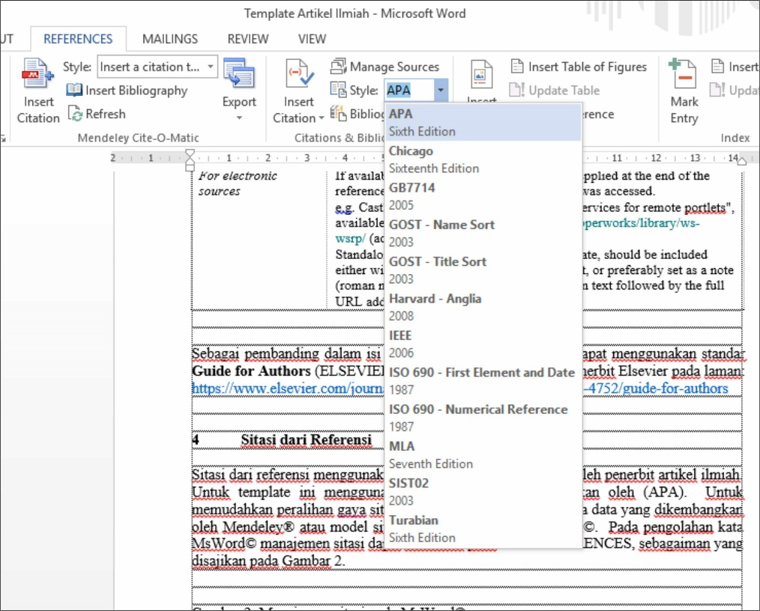

Gambar 2. Manajemen referensi pada MsWord©

4 Isi Karya Ilmiah

Isi dari artikel umumnya memuat:
a Judul
b Nama penulis dan afiliasinya
c Abstrak
d Batang tubuh artikel
(1) Pendahuluan
(2) Metodologi/ Desain/ Pendekatan
(3) Hasil dan Pembahsan
(4) Kesimpulan
e Ucapan terima kasih (apabila ada dan diperlukan)
f Nomenklatur/ Daftar Istilah (apabila ada dan diperlukan)
g Daftar Pustaka

Ucapan Terima Kasih

Ucapan terima kasih dan penghargaan disampaikan penulis atas dukungan dari Sekolah Tinggi Agama Islam Al-Musaddadiyah Garut yang telah memberikan dana bagi penelitian dan publikasi karya ilmiah yang bersumber dari ??????, melalui kontrak nomor: #############.

Daftar Pustaka

ELSEVIER. (2017). Guide for Authors. Retrieved 1 27, 2017, from ELSEVIER: https://www.elsevier.com/journals/learning-and-instruction/0959-4752/guide-for-authors
Emerald Publishing. (2017). Author Guidelines. Retrieved 1 27, 2017, from Emerald Publishing: http://www.emeraldgrouppublishing.com/products/journals/author_guidelines.htm?id=JHOM
Pribadi, B. A., & Delfy, R. (2015). Implementasi Strategi Peta Konsep (Concept Mapping) dalam Program Tutorial Teknik Penulisan Artikel Ilmiah. Jurnal Pendidikan Terbuka dan Jarak Jauh, 16(2), 76-88. Retrieved from http://jurnal.ut.ac.id/JPTJJ/article/view/408/421
Rohmah, N., Huda, M., & Kusmintardjo, A. Y. (2016). Strategi Peningkatan Kemampuan Dosen dalam Penulisan Karya Ilmiah (Studi Multi Kasus pada UNISDA dan STAIDRA di Kabupaten Lamongan). Jurnal Pendidikan, 1(7), 1312-1322. Retrieved from http://journal.um.ac.id/index.php/jptpp/article/view/6560/2795

